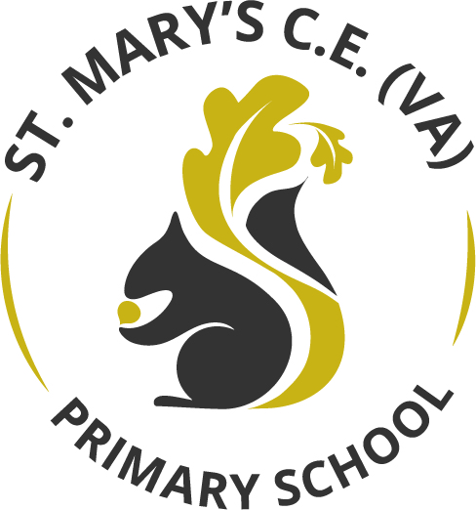

Geography Curriculum Statement

January 2022

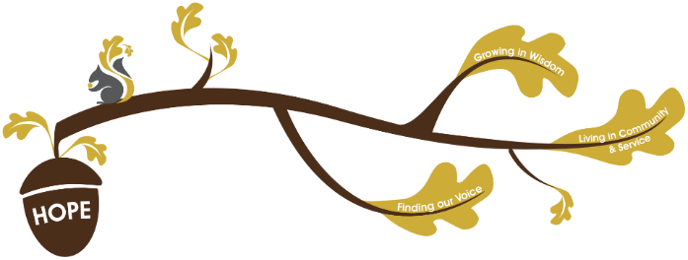
Rational / Vision
Founded in hope St. Mary’s CE (VA) Primary School is a place where all can find their voice, grow in wisdom and live well in community and service.

Geography plays a fundamental role in realising our school vision.
Finding our voice: Oracy is core to our geography curriculum, through discussions and exploration children are able to discover an awe about the world around them. At St Mary’s we feel that practical experiences will allow children to have powerful discussions about the local environment and the wider world.
Living in Community and service: Our local community is at the heart of our geography curriculum. With every year exploring their local environment which builds up over the curriculum. Our community and local environment are at the core of the children’s knowledge. We want children to have a depth of understanding about the community in which they live and be able to use this to their advantage. Then from this they can show service to comparison countries and be able to debate about the similarities and differences.
Growing in wisdom: Our geography curriculum allows children to grow in wisdom across 4 conceptual pillars these are: locational knowledge, place knowledge, human and physical geography and geographical skills and fieldwork.

Intent
In ensuring high standards of teaching and learning in geography, we implement a curriculum that is progressive throughout the whole school. From EYFS to Year 6 we have a set of geographical concepts which are central to the Geography subject knowledge map as the conceptual pillars, these are:
- Locational knowledge
- Place knowledge
- Human and Physical Geography
- Geographical skills and fieldwork
Starting with the Early Years Foundation Stage who lay the foundations using the guidance from the ‘Development Matters’, which aims for all children in Nursery and Reception to have an ‘Understanding of the World’. This is followed by Key Stage One exploring and investigating the local area and the United Kingdom and then look at around the world to build up locational knowledge. Building on from these skills the children compare and contrast the differences and similarities between Wakefield and a small town in Africa.

By the end of Year Six we aim to have confident and well-rounded geographers who can use the skills they have learnt to read maps, investigate different countries and physical processes. Children who can present arguments and conclusions found in human geography, and who are aware and have opinions on in the moment, real life issues e.g. climate change. Year Six children will leave St Mary’s as responsible citizens with a set of core values.

At St Mary’s, Geography is taught as part of a half termly topic, focusing on knowledge and skills stated in the National Curriculum. We ensure that geography has the same importance given to it as the core subjects, as we feel this is important in enabling all children to gain ‘real-life’ experiences. Through high quality planning and teaching our ultimate aim is to ensure as many children as possible achieve greater depth in their learning. This is completed through scaffolding children and ensuring learners are supported in line with the school’s commitment to inclusion. Outcomes are reviewed to ensure that the reflect a sound understanding of the key identified knowledge and skills.

At each stage of their learning, children will deepen their locational knowledge, place knowledge and understanding of human and physical geography. Geographical skills will be built upon at each stage, providing children with skills to successfully navigate and engage with their world at a local, national and international level.

Subject Provision/ Implementation
Our Geography curriculum has a practical approach to enable children to understand the knowledge they’re being taught. Aspects of this include:
- Photographs and videos.
- First hand experience in the local environment.
- Oral contributions so that children can discuss and think critically.
- Art references based around the geographical topic.
Within our enquiry-led Geography curriculum, we seek to enable children to have the skills, knowledge and understanding they need to think creatively and critically, to investigate and to ask questions to enable them to gain a greater understanding, knowledge and appreciation of the world and their place in it. Pupils learn new vocabulary to allow them to discuss common themes of locational knowledge, place knowledge, human and physical geography and fieldwork.
Our curriculum allows for knowledge to be built upon to allow for knowledge to be transferred into children’s long-term memory. Allowing for local and wider world knowledge to be deepened throughout the year groups.
Outdoor learning experiences will be at the heart of children’s Geography learning. Children will begin to develop their fieldwork and observational skills by studying their school and its grounds before carrying out a more detailed study of the local area in Key Stage 2, including weather patterns, environmental impact and changes.
Technology and high-quality texts, will be used to enrich children’s locational and place knowledge as well as developing their understanding of human and physical geography, diverse places and peoples. We encourage children to draw upon the skills taught across the curriculum to support them in their geography learning. The teaching of Geography will be rich in first-hand learning experiences. Educational visits within the local community will be used to enrich the learning experiences of all children and promote awe and wonder.

Impact
In following the Geography curriculum, our expectation is that all pupils are Geography literate and as a minimum pupil are able to:
- Talk about their local environment starting with changes in seasons, human and physical features,
- Communicate in a range of ways to show their knowledge and understanding of aspect of the United Kingdom and the wider world.
- Use a wide range of geographical terms and vocabulary in context. Such as being able to identify and name places, the features within them and the human and physical processes at work there. Such core knowledge provides the building blocks of deeper explanation and understand; providing entry points to geographical conversations about the world.
- Show skills of investigation, map reading, weather recording, understand and explain the physical structure of earth (including volcanoes).

Outcomes show evidence of a broad and balanced geography curriculum and demonstrates the children’s acquisition of identified key knowledge and skills. Children have opportunities and are encouraged to review their own successes at the end of each session as well as identifying their own target areas, with teacher support. The impact and measure of this is to ensure that the children at St Mary’s are equipped with geographical skills and knowledge that will enable them to be ready for the curriculum at Key Stage Three and for life as an adult in the wider world.

