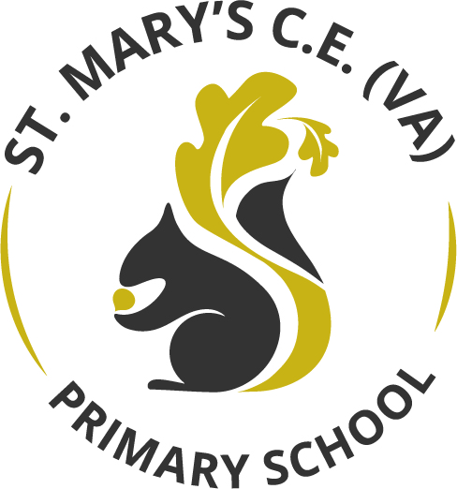

Art and Design Curriculum Statement

September 2022

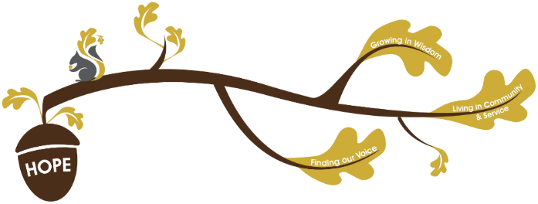
Rational / Vision
Founded in hope St. Mary’s CE (VA) Primary School is a place where all can find their voice, grow in wisdom and live well in community and service.

The Art and Design curriculum plays a fundamental role in realising our school vision.
Finding our Voice - Oracy is an important part of Art and Design lessons. We give our children a voice to talk about processes they are using and exploring. We enable children to communicate what they see, feel and think. They have opportunities to critically evaluate their work and the work of others through discussion, using vocabulary that reflects the breadth of their concrete experiences.
Grow in Wisdom – Children are inspired by the work of artists, themes and style they study and develop skills and vocabulary to inspire their personal expression. They grow in appreciation of the world around them and its art and how they can articulate their personal thoughts and feelings in response to it. Children become aware of careers that are driven by art – artists, graphic designers, architects, sculptors – allowing them to feel inspired in the choices they could make in their lives.
Living in community and service – Children develop an understanding of the impact that Art has had on contemporary life, on life in different periods in the past and on different cultures, including in the communities at the heart of our school. For example, through links with the Hepworth Wakefield and Nyamisisi school in Mara, Tanzania, we make links to Art within our local and global community. When exploring different kinds of Art children see that it is everywhere and an integral, inspirational part of our world.

Intent
The Art and Design curriculum is structured around core skills in drawing, painting and other techniques and processes. Each year group has clear guidance and progression for the knowledge, key elements and concepts, exploration of media and ideas and reference to work of other artists which informs planning.
These elements form the conceptual pillars for the sequencing of learning across school:
- Skills
- Knowledge and key elements
- Explore and experiment with media and ideas
- Reference to work of other artists
- Outcome
Each year group plans developments in these conceptual pillars through their class units of work which are evident on the subject knowledge map.

Provision / Implementation
- Key features and approaches in the subject involve exploration and discussion of the work of other artists, opportunities for developing skills using a range of media and final projects which allow children to apply what they have learnt in their own final outcome piece of work.
- Careful thought is given to promoting oracy and a vocabulary rich curriculum. Children explore, discuss and communicate their evolving ideas gained through as many concrete experiences as possible.
- Sketchbooks evidence key vocabulary, thought processes, choices, skill development and evaluations. Sketchbook comments reflect growing confidence to experiment and develop personal responses. Children comment critically on their own and others’ work.
A record of photographs of final pieces of work is kept on the school network at the end of each class unit.
- Each class displays work on the whole school display which evidences final outcomes, key vocabulary and progression between year groups.
- Subject leaders ensure that the correct resources are available for staff to teach the required skills. Class teachers notify the subject leaders in advance of the half term’s work if more resources are needed.
- Teachers use their professional judgements when assessing children’s work. They look for evidence of key skills and knowledge and understanding of the key elements and concepts. These will be evident through sketchbook work, written and oral comments and final outcomes. Teachers use these to inform their feedback to children and their future planning. Subject leaders monitor Art and Design currently through sketchbook scrutiny, capturing pupil voice and monitoring final outcomes in photographs and the whole school Art display. When monitoring sketchbooks subject leaders look for coverage against the subject knowledge map’s conceptual pillars. Discussions with pupils determine the impact their learning has had.
Entitlement
Largely, Art units will be delivered weekly with lessons progressing from sketch book work to a final outcome piece.
Where the skills being taught and equipment needed (e.g. paint and clay) require time to be used more flexibly, the unit can be delivered in a block of time.
Impact
In following the Art and Design curriculum, our expectation is that all pupils are artistically literate and as a minimum pupil are able to:
- use specific Art vocabulary correctly within discussions and sketch book annotations.
- manage and control media.
- have drawing and painting skills which are continually and progressively developed
- have the ability to control pencil with accuracy and to create line, tone, texture and pattern appropriately with accuracy and control.
- know how to control paint, use different paintbrushes, mix and manage different paints and create different paint effects.
- explore other techniques and processes such as clay, printmaking and textiles (see subject knowledge map).
- safely use equipment and develop technical skills.
- use sketchbooks as a research tool and record of thoughts.
- experience the key elements of Art throughout a wide range of themes and topics.
- talk about Artists that have influenced their work.

By following our Art and Design curriculum a child will be able to:
- have key painting and drawing skills and work with accuracy, control, observation and knowledge of media.
- record from first-hand experience and from imagination and select their own ideas based on their exploration.
- express knowledge of how Art has been used in past and contemporary society and its role in many cultures.
- show an enjoyment and appreciation of the visual arts and a knowledge of artists, craftspeople and designers.
- speak with confidence about their learning in art.

